Banyule District Cubs
Founders Day Activity 2017 is a Bike Ride:
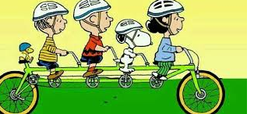

Sunday 26th February 2017
Start time 10.00
Possum Hollow Playground Beverley Rd. Heidelberg
Riding to:
Greensborough Scout Hall – Willinda Park, Beatrix Ave Greensborough
ETA Greensborough Scout Hall 12.30
At Greensborough Scout Hall, we will have a sausage sizzle.
No charge for the sausage sizzle
Cubs collection at 2.00 pm
Cubs wear uniform & helmet
Please pack:
- Snacks
- Water bottle
- Medications
No Scooters or bikes with training wheels
Adult/Youth Helpers are welcome to attend.
For catering purposes please respond
RSVP Tuesday 21st February at the latest.

Wayne (Akela)
akela@rosannacubs.org

